Smart Farmer-IOT Enabled Smart Farming Application
IBM NALAIYATHIRAN
SPRINT DELIVERY – 3

TITLE | Smart Farmer-IOT Enabled Smart Farming  Application
DOMAIN NAME | INTERNET OF THINGS
TEAM ID | PNT2022TMID47004
LEADER NAME | ADLIN J
TEAM MEMBER  NAME | BOOMIKA G  DURGA DEVI B  PREETHA M
Configuration of Node-Red to send commands to IBM cloud
ibmiot out node I used to send data from Node-Red to IBM Watson device. So, after
adding it to the flow we need to configure it with credentials of our Watson device.
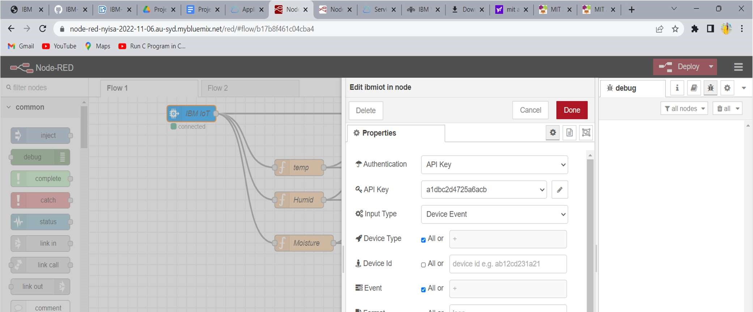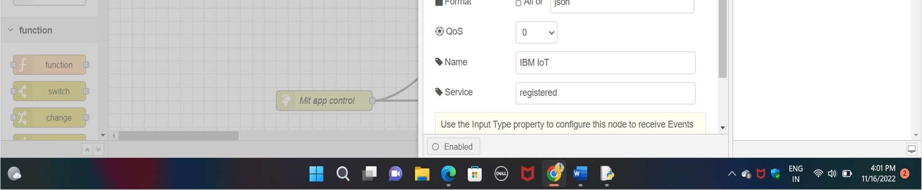
Here we add two buttons in UI
- -> for motor on
- -> for motor off
We used a function node to analyses the data received and assign command to each number.
The Java script code for the analyses is: if(msg.payload===1) msg.payload={"command”: “ON"};
else if(msg.payload===0)
msg.payload={"command”: “OFF"};

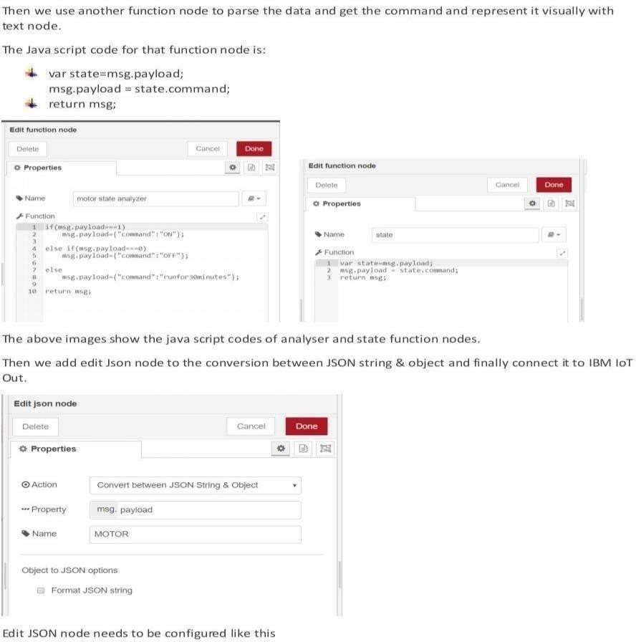
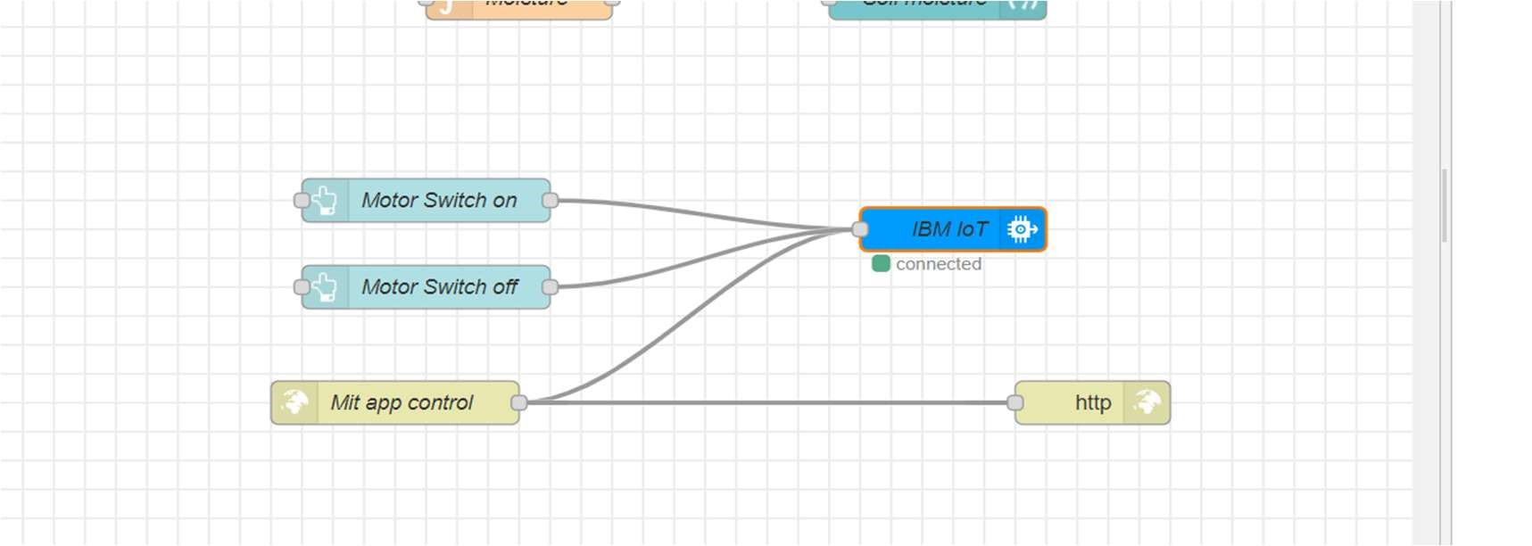

This is the program flow for sending commands to IBM cloud.

Adjusting User Interface
In order to display the parsed JSON data a Node-Red dashboard is created
Here we are using Gauges, text and button nodes to display in the UI and helps to monitor the parameters and control the farm equipment.
Below images we started to create the flow 1

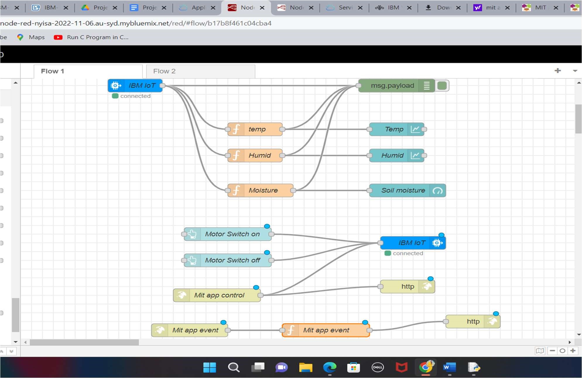
COMPLETE PROGRAM FLOW :

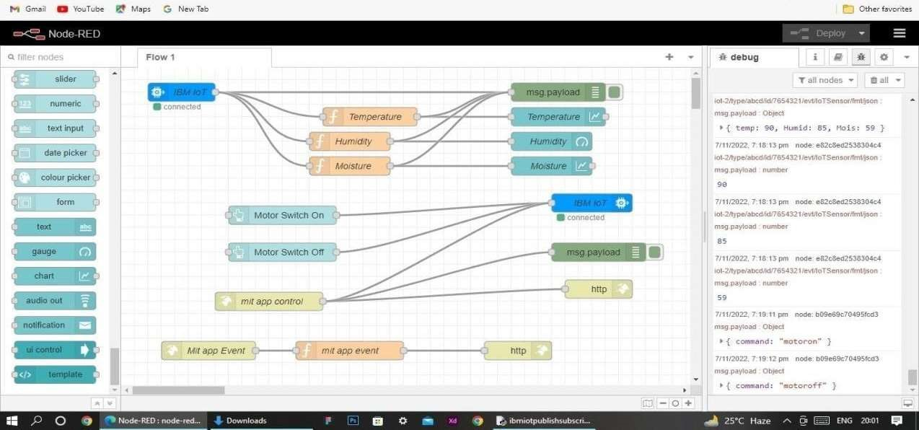

MOBILE APP WEB :
BLOCK DIAGRAM
